HOW TO GET THERE
- By Tramway Line 1
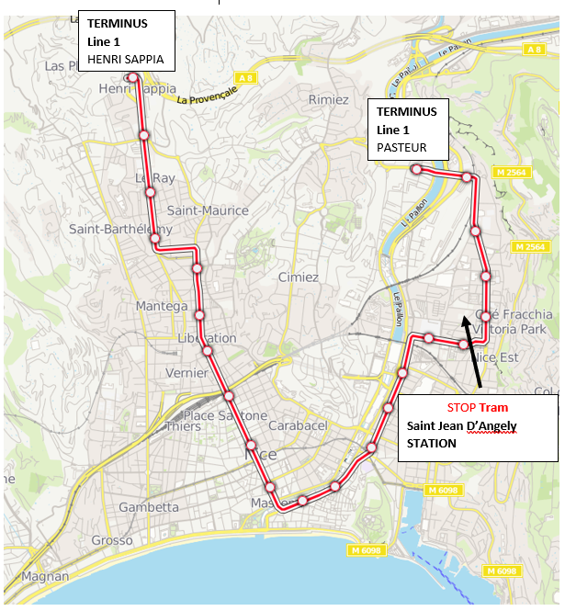
- STOP to Saint Jean D’Angely
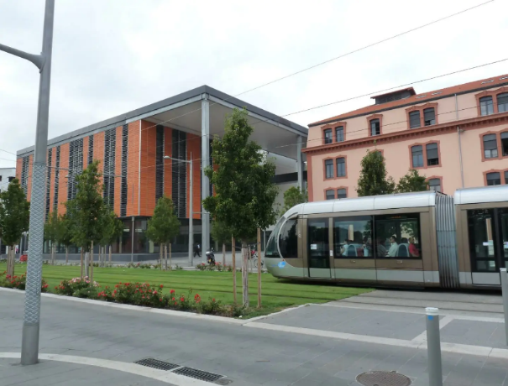
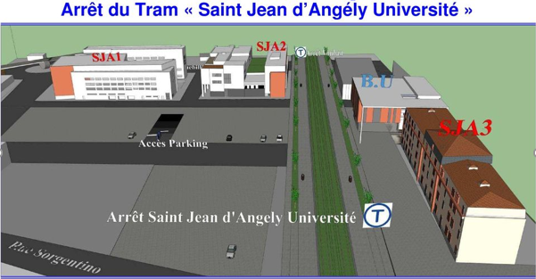

SAINT JEAN D’ANGELY 3 MSHS Sud-Est
Address : 25 Avenue François Mitterrand, 06300 Nice
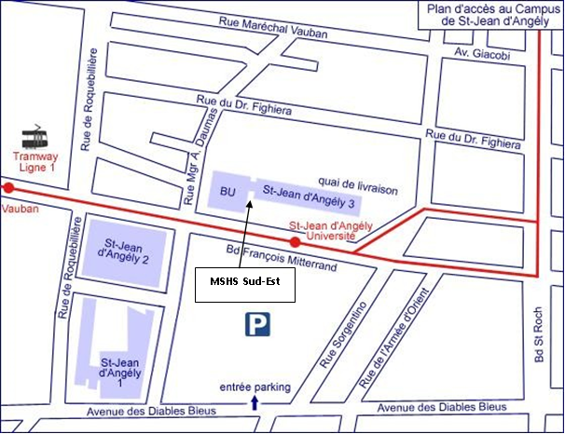

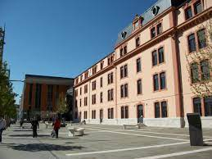
MSHS Sud-Est
16th ISGEP WORKSHOP

